**EMPLOYEE MOVEMENT TEST RESULT**

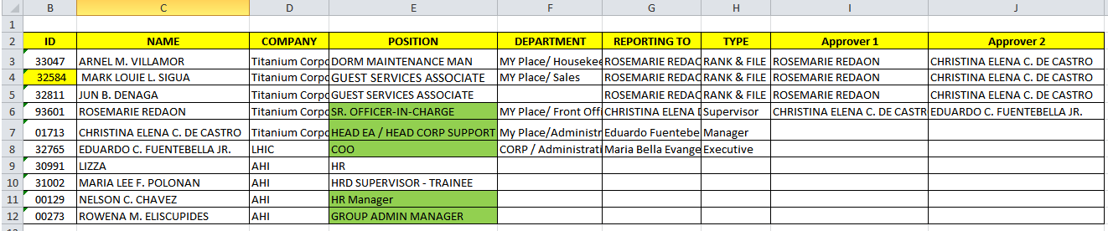

1. Personal Tab ( Resignation Movement) – Remove on the listing Reason and further Reason.

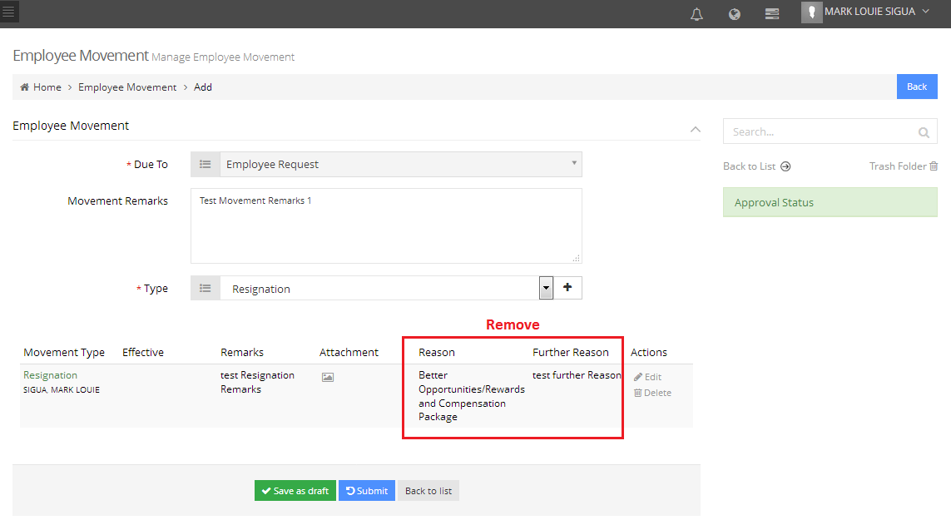

Done

1. Admin Tab (Resignation Movement) – Remove on the listing Reason and further Reason.

* What is the Access Role for HR Staff
* What is the Access Role for Review by
* What is the Access Role for HR Approver 1
* What is the Access Role for HR Approver2

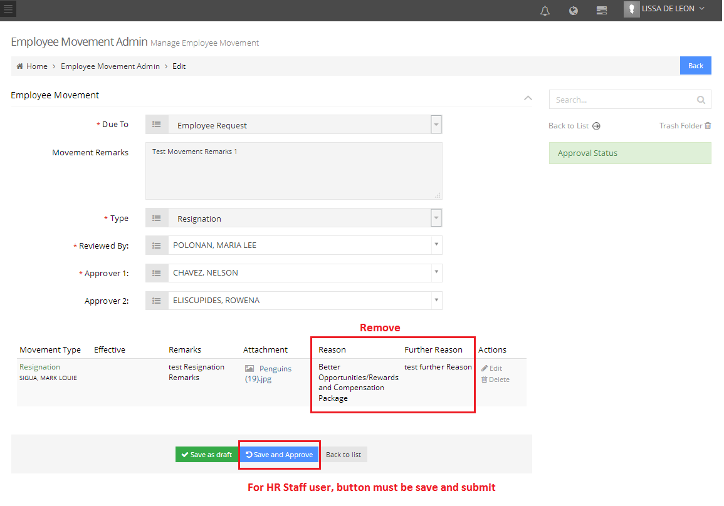

Done

Done

1. 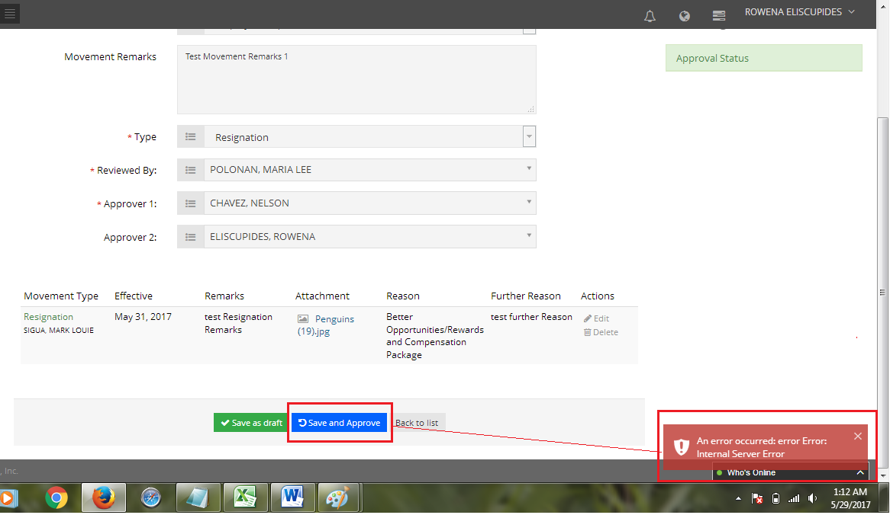I tried na HR Administrator muna role ng HR Staff , Reviewed by, HR Approver 1 and 2 paratumuloy approval process. Pag dating kay approver to. I encountered

Done

1. I tried Save as Draft

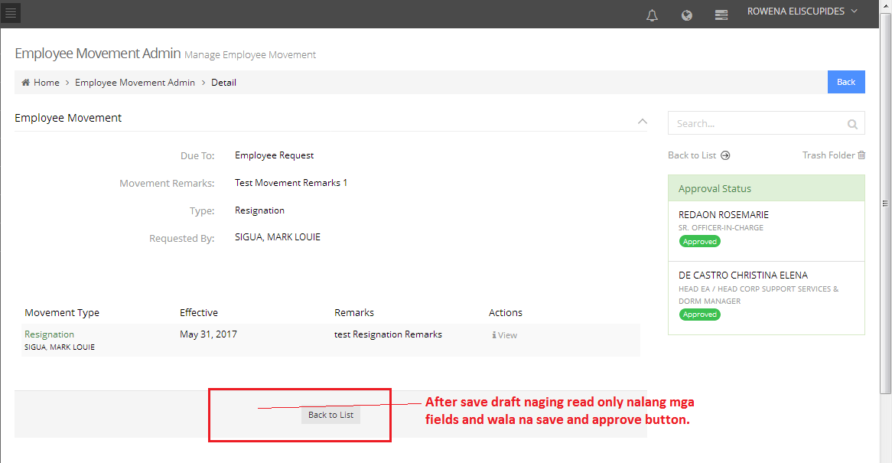

Done